 | 14.3.1 Editors - Video Sequence Editor - Sidebar - Preview - Tool tab
Table of content
Tool Tab 1
Active Tool panel 1
Metadata panel 1

Tool Tab

In the tool tab you will find the tool related settings for the tools in the tool shelf.

Active Tool panel

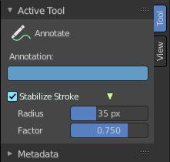
Displays the settings for the tools in the tool shelf. These settings are explained in the tool shelf chapters.

Metadata panel
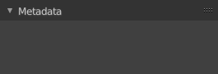
Displays existing metadata of the strip content.

